Lab Assignment 6 Omkar Ashok Kalange

1. Imported the csv file –

> d=read.csv('assignment_6.csv',header = TRUE,sep=',')

> head(d)

x y

1 6.277005 6

2 11.108959 5

3 8.716725 5

4 65.277554 8

5 8.651929 7

6 2.792035 2

1. Bestfit of x = Gamma Distribution

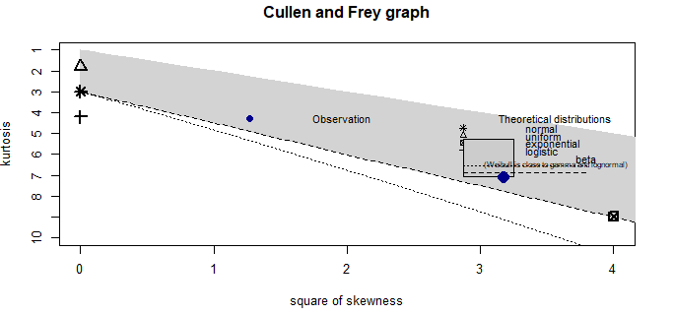

Bestfit of y = Normal Distribution

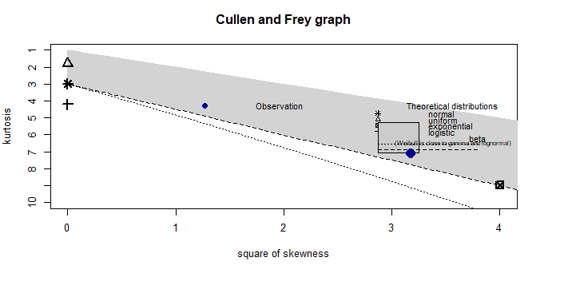

Goodness of fit plots for x:

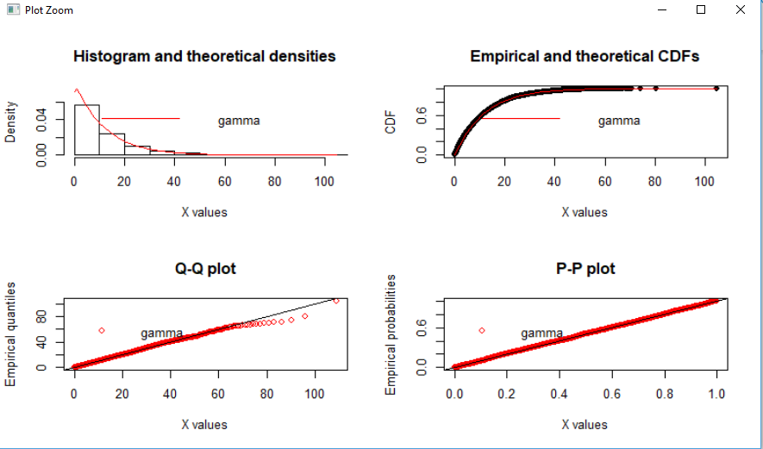

Goodness of fit plots for y :

